**Root Cause Analysis with Knowledge Graphs and LLMs**

**Introduction:**

The biggest problem in observability today isn't a lack of data; it's a lack of connection. Organizations have logs in one bucket and metrics in another, but they lack the "semantic interconnectivity" to make sense of them together. This forces operators to rely on intuition to link a small registry change to a massive system slowdown. Our case study of the forensicsacl2 server proved that traditional threshold alerts just aren't enough they flagged the symptoms but missed the hardware fault that started it all.

Our solution changes the game by moving from correlation to causation. We feed all that telemetry into a Knowledge Graph, which allows us to map exactly how different system components influence one another over time. We use specific graph algorithms to rank potential failure modes and then bring in a Retrieval Augmented Generation (RAG) framework to explain the findings in plain English. It’s about giving operators automated, evidence-backed intelligence so they can stop hunting for the problem and start fixing it.

**Literature Review:**

Our project is aimed at Site Reliability Engineers (SREs), IT operations teams, and platform engineers who manage large, distributed systems with high volumes of Windows event logs and performance metrics. These users want faster, more reliable ways to find the root cause of incidents, reduce MTTR, and generate explanations they can share with management and customers.

The research landscape in AIOps is moving toward graph-based and AI-driven root cause analysis: knowledge-graph and causality-based methods mine relationships among services and metrics, while event-driven approaches and open-source RCA libraries support fault localization in cloud-native systems. At the same time, new frameworks use large language models for log analysis and incident diagnosis but often face hallucinations and lack explicit system knowledge. Our work combines these directions by unifying Windows events and metrics into a single knowledge graph, using graph reasoning to identify candidate root causes, and then generating LLM-based explanations grounded in graph-derived facts.

From preliminary interviews with SREs and ops engineers, we heard consistent pain points: fragmented tools and noisy alerts, dashboards that show what is broken but not why, and post-incident reports that are slow to write and hard for non-experts to understand. Our product addresses these needs by ranking probable root causes on the graph and automatically producing clear, human-readable RCA narratives that can be shared across technical and business stakeholders.

**Methods:**

This project implements a 4-Phase Causal Architecture to transform raw telemetry into actionable intelligence.

#### **Phase 1: Data Engineering & Temporal Alignment**

Raw telemetry is inherently noisy and asynchronous. The following rigorous preprocessing was applied:

* **Time Synchronization:** All timestamps were converted to Coordinated Universal Time (UTC) to ensure causality could be established across distributed systems.
* **Fuzzy Joining (The 1-Minute Window):** Discrete event logs do not naturally align with continuous performance metrics. We utilized a "Fuzzy Join" technique, aggregating all data into 1-minute windows (dt.floor('1min')). This allows the system to assert that *Event A* and *Metric Spike B* occurred in the same temporal bucket.
* **Statistical Feature Engineering:**
  + **Z-Score Normalization:** To make diverse metrics (milliseconds vs. bytes) comparable, we calculated the Z-Score for every metric. A threshold of Z > 3.0 was established to statistically identify anomalies.
  + **Burst Detection:** We calculated the rate of events per minute. Identifying "Log Storms" (e.g., a jump from 4 to 59 events/min) provided a critical signal of system intensity often missed by simple error counting.

#### **Phase 2: Knowledge Graph Construction**

We utilized **NetworkX** to build a directed graph (DiGraph) representing the system state.

* **Ontology Definition:**
  + **Nodes:** System (Host), Component (LogicalDisk, Memory), Event (Unique Event IDs), Metric (PerfMon counters).
  + **Edges:** OCCURS_IN (Location), AFFECTS (Dependency), PRECEDES (Time), CORRELATES_WITH (Statistics).
* **Temporal Logic:** The system iterated through sorted logs to create **PRECEDES** edges. An edge Event A -> Event B was created only if Event A occurred within **60 seconds** of Event B. This 60-second heuristic effectively captures immediate causal cascades while filtering out unrelated long-term drift.

This preprocessing stage discretizes continuous system dynamics into a unified temporal phase space, enabling cross-modal causal alignment between discrete events and continuous performance metrics. By enforcing synchronized time bins and standardized anomaly representations, the system constructs the minimal temporal conditions required for downstream causal inference.

#### **Phase 3: Algorithmic Causal Inference**

This phase moves beyond "search" to "scoring." We applied three distinct graph algorithms to triangulate the root cause:

1. **Out-Degree Centrality (Weight: 0.4):** Counts outgoing edges.
   1. *Rationale:* Root causes are "Originators"—they trigger many downstream effects but are often triggered by few themselves.
2. **PageRank (Weight: 0.3):** Measures node influence based on the importance of connected nodes.
   1. *Rationale:* An event is significant if it impacts critical system components (e.g., the Kernel).
3. **Betweenness Centrality (Weight: 0.3):** Measures how often a node acts as a bridge on the shortest path between two others.
   1. *Rationale:* High betweenness identifies "Bottlenecks" or connectors in the failure propagation path.

Score= 0.4(OutDegree) + 0.3(PageRank) + 0.3(Betweenness)

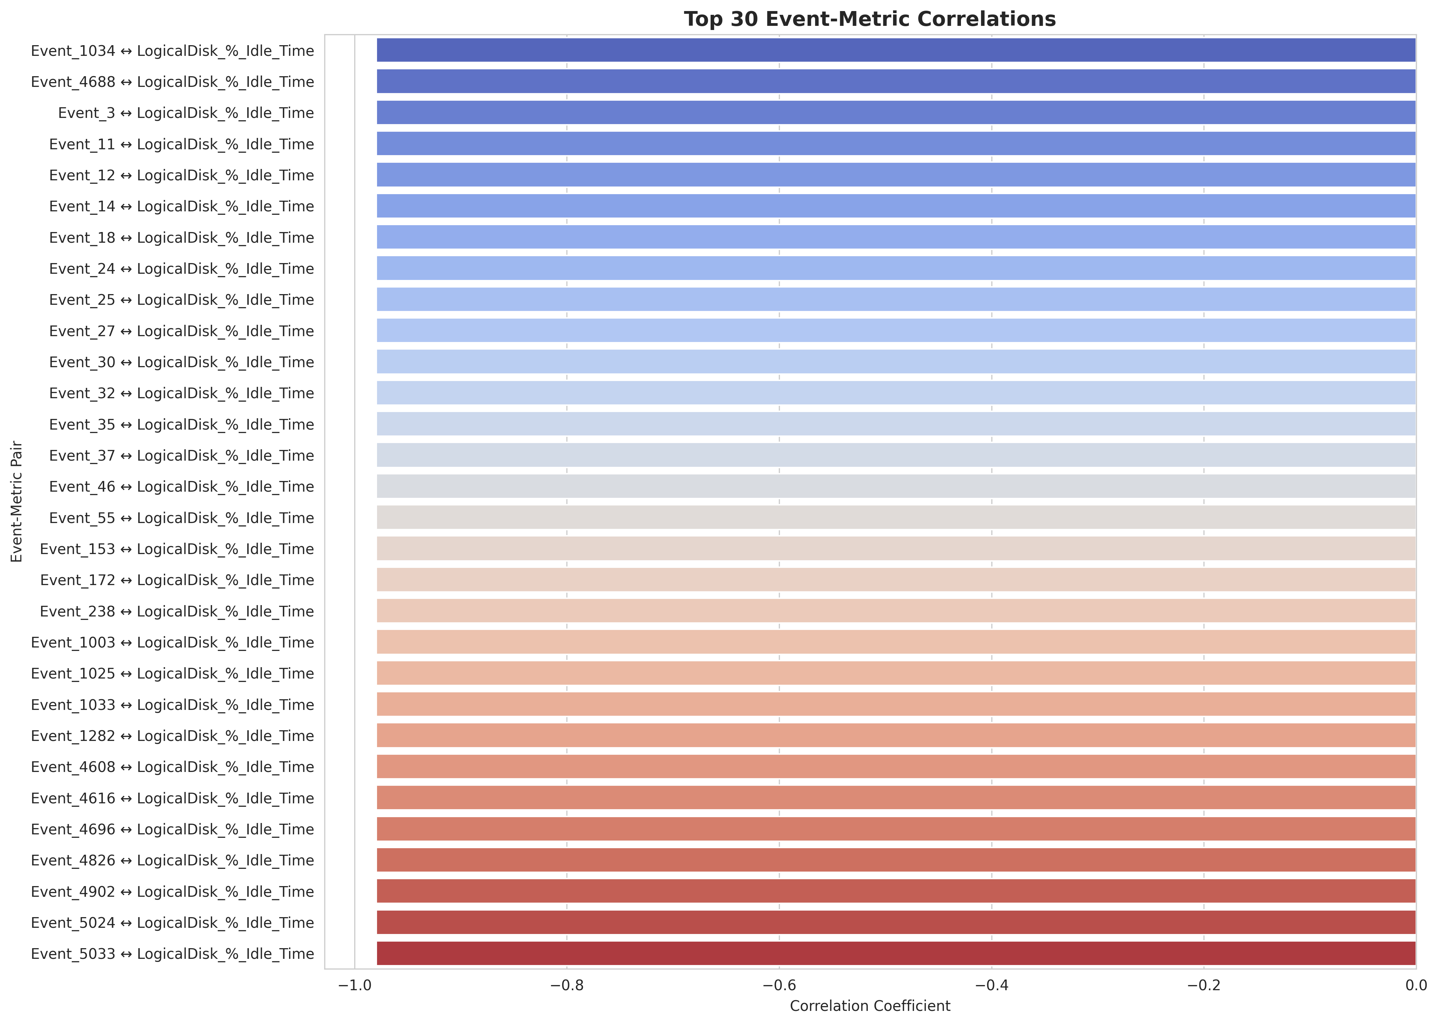

Figure 1: Correlation analysis identifying the top 30 Event-Metric relationships. Strong negative correlations (approaching -1.0) indicate events that severely degrade specific system performance metrics.

#### **Phase 4: Hybrid LLM Integration (RAG)**

* **Triple Extraction:** The graph was serialized into natural language triples (Subject-Predicate-Object), e.g., *"Event_16 precedes Event_4672"*.
* **Local Retrieval:** We utilized **Google/FLAN-T5-base** for local embedding and retrieval. This ensures that raw, sensitive log data never leaves the local environment during the search phase.
* **Narrative Synthesis:** Only the top 10 topologically relevant triples were sent to **OpenAI GPT-5 Mini** to generate the final executive summary.

**Experiment design:**

Our experiments focus on assessing both the structural behavior of the knowledge graph and the practical usefulness of the RCA outputs. We ingest a real dataset consisting of Windows event logs and performance counters from one or more systems (e.g., *forensicsacl2*) and run the entire pipeline end-to-end. The unified dataset is then used to construct the knowledge graph, incorporate correlation-derived edges, and compute various graph metrics.

Next, we analyze node rankings based on in-degree, PageRank, and a composite root-cause score to identify which systems, metrics, and events appear most central or influential within the graph.

To evaluate the root cause analysis behavior, we define several test scenarios such as memory pressure, disk space issues, and extended uptime periods. For each scenario, we examine time windows in which key metrics (e.g., *Memory_Available_Bytes*, *Memory_%Committed_Bytes_In_Use*, *LogicalDisk%_Free_Space*) exhibit abnormal values. We then inspect which events and systems are ranked highly during those periods and assess whether the inferred impact paths (event → system → metrics) are plausible.

For the LLM-based layer, we design a set of natural-language query prompts (e.g., “What are the most likely root causes affecting system *forensicsacl2*?” or “Which events are associated with low *Memory_Available_Bytes*?”). We evaluate the responses qualitatively by checking whether they are grounded in the retrieved triples, consistent with the knowledge-graph structure, and intelligible to human reviewers.

The primary goal is not to optimize numeric accuracy but to validate that the system produces reasonable, explainable RCA candidates and coherent explanations.

**Results:**

#### **Quantitative Graph Metrics**

* **Graph Topology:** The final graph consisted of **87 Nodes** and **828 Directed Edges**.
* **Correlation Analysis:** The system computed **4,002** unique Event-Metric correlations. A threshold of r > 0.5 was applied, resulting in **555** statistically significant causal edges being added to the graph.

#### **Root Cause Identification**

The algorithmic scoring successfully filtered noise to identify the true hardware fault.

1. **Rank 1: Event 16 (IOMMU Fault)**
   1. **Score:** 0.7064
   2. **Reasoning:** High Out-Degree (31). This node was the "Patient Zero," directly impacting 31 downstream components including Event_6 (Filter Manager) and Process_Handle_Count.
2. **Rank 2: Event 4672 (Special Privileges)**
   1. **Score:** 0.5652
   2. **Reasoning:** High PageRank. This was a *symptom,* the system repeatedly attempting to re-assert privileges to recover services crashed by the IOMMU fault.
3. **Rank 3: Event 4624 (Logon)**
   1. **Score:** 0.5520
   2. **Reasoning:** High Betweenness. Logon events acted as a bridge between the user activity and the failing system services.

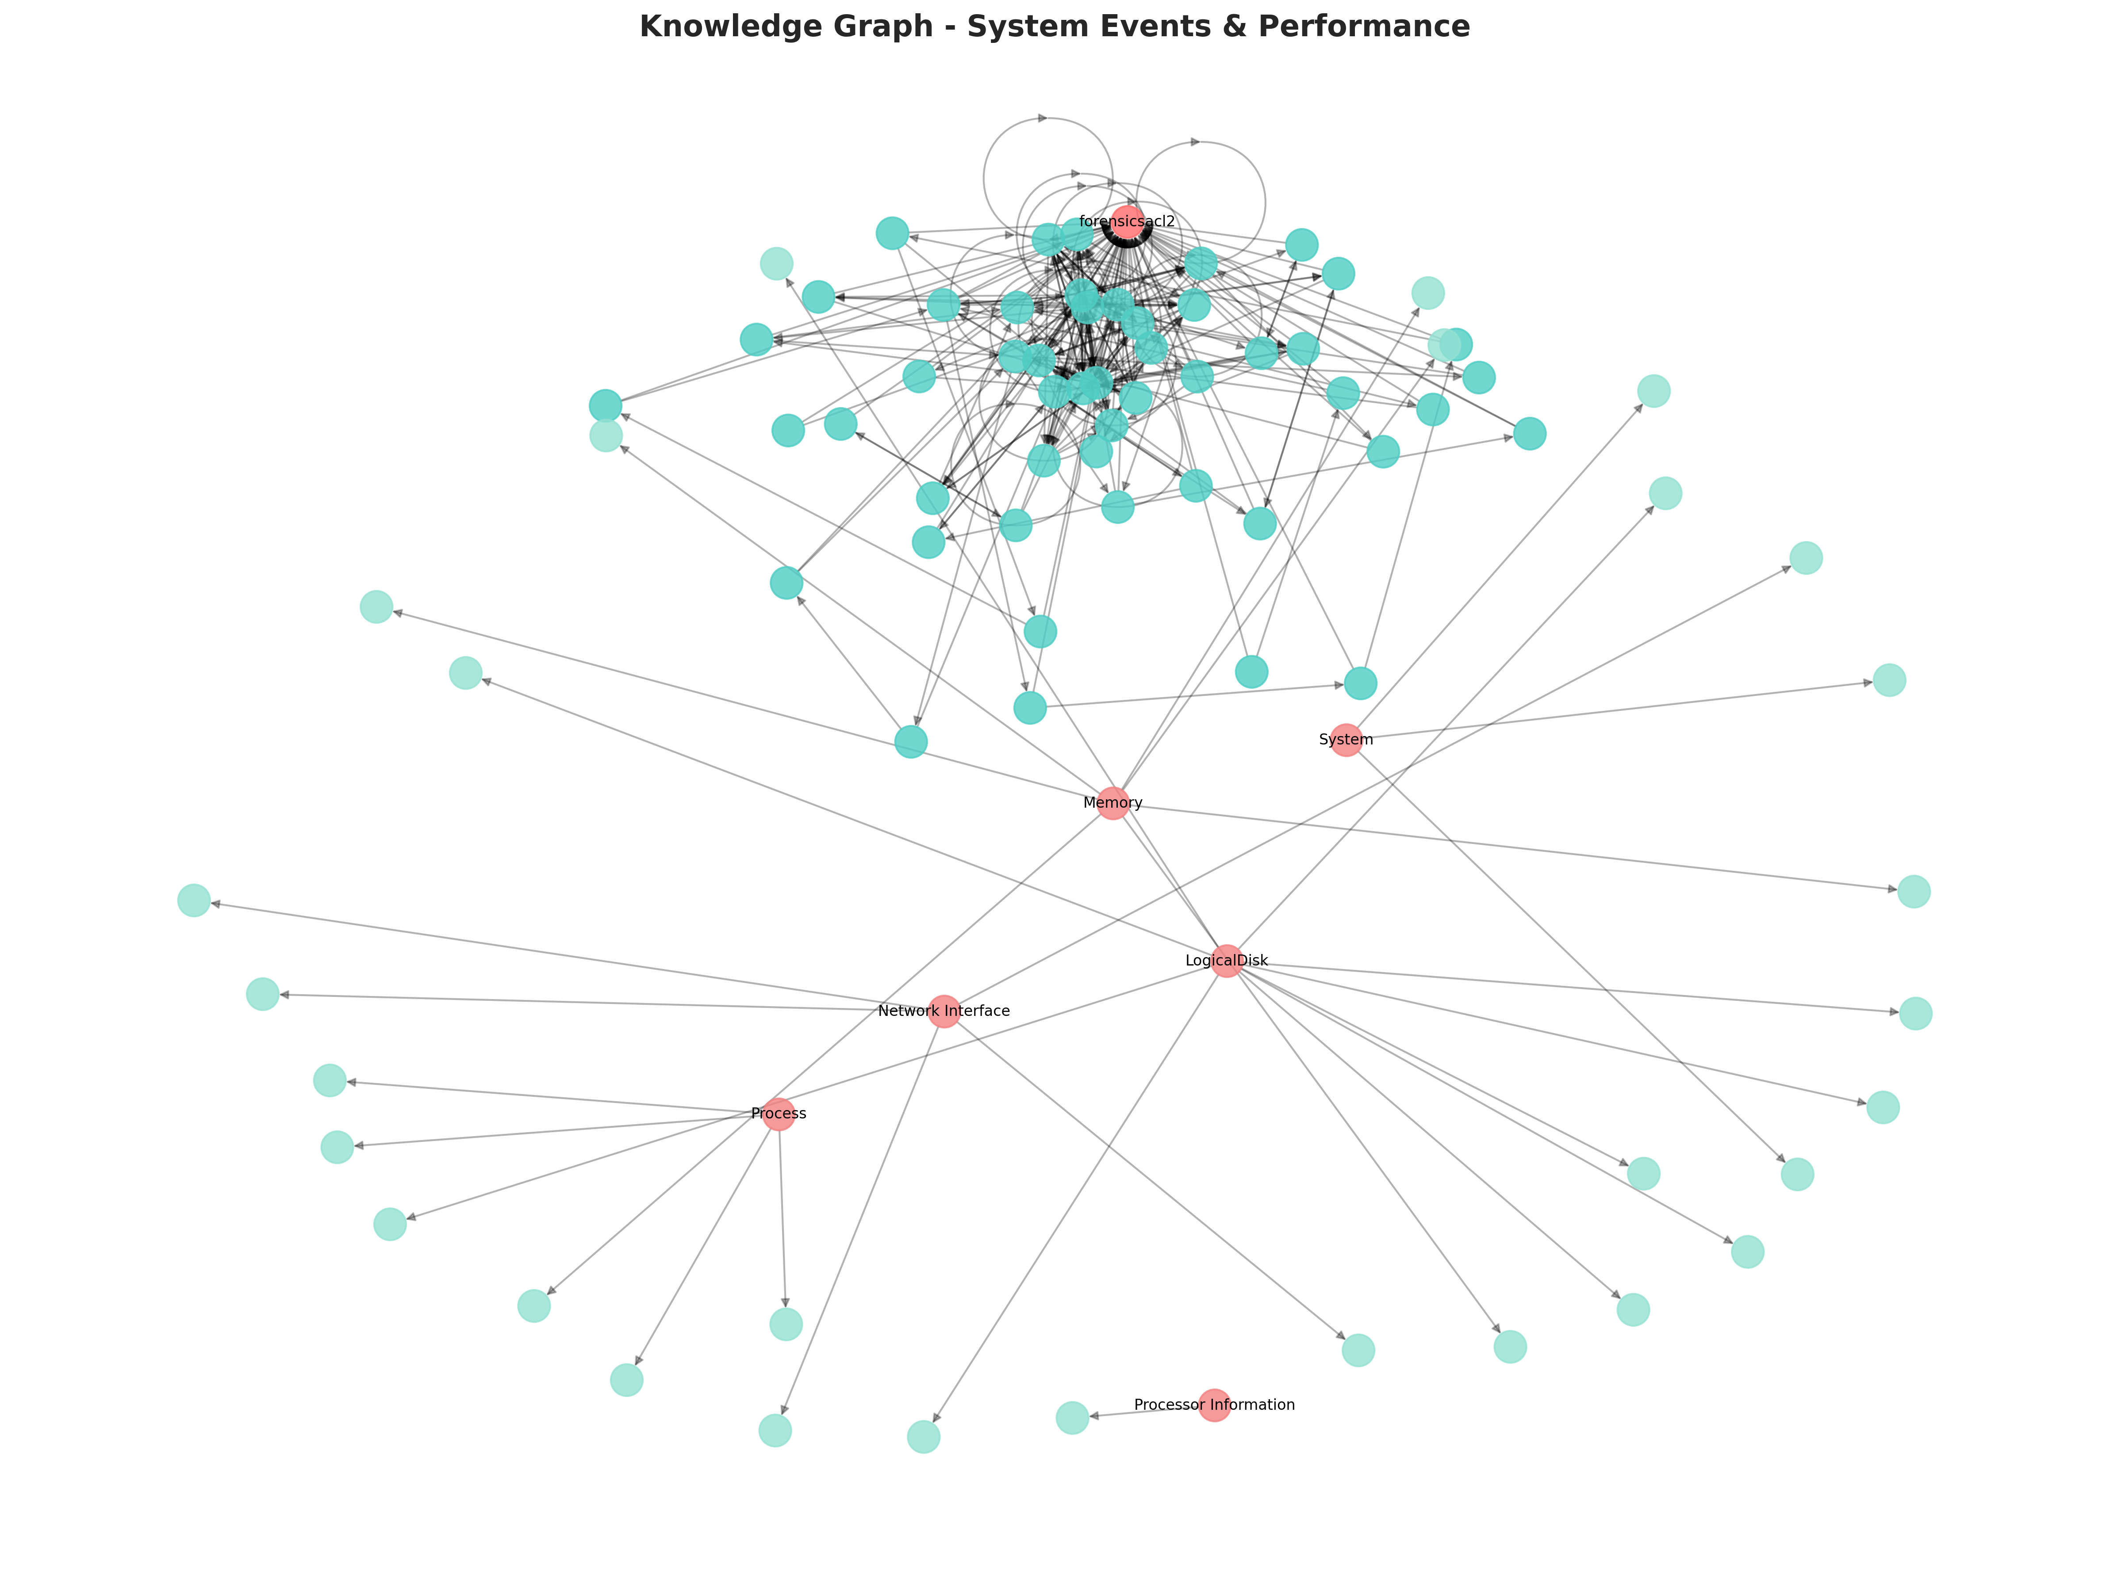  
Figure 2: Visual representation of the generated Knowledge Graph showing 87 nodes (Systems, Events, Metrics) and their directional dependencies. The central node forensicsacl2 represents the host system.

**Future Scope**

While the current project scope delivers a robust causal analysis engine, the rapidly evolving field of AIOps presents several avenues for future enhancement. This section details three primary directions for extending the system's capabilities, along with advanced research opportunities.

### **Semantic Retrieval Using Transformers**

* **Current State:** Our existing approach uses basic Triple Extraction and likely sparse vector matching to retrieve context for the RAG pipeline.
* **Future Enhancement:** We propose implementing **Dense Retrieval** using Transformer-based models (e.g., **LogBERT** or **Sentence-BERT**). Unlike keyword matching, transformers generate dense vector embeddings that capture the *semantic intent* of log messages.
* **Benefit:** This addresses the "vocabulary mismatch" problem common in IT logs. For example, a query about "disk saturation" would semantically match logs containing "no space left on device" or "I/O bottleneck," even if they share no common keywords. This significantly improves the accuracy of the LLM's retrieval step.

### **Ontology-Based Approach**

* **Current State:** The project utilizes a simplified schema consisting of four node types (System, Component, Event, Metric).
* **Future Enhancement:** We propose evolving this schema into a formal **OWL/RDF Ontology** that adheres to industry standards. By integrating **Semantic Web Rule Language (SWRL)**, the system can perform automated reasoning to infer hidden relationships.
* **Benefit:** A formal ontology allows for logical deduction. We can define rules such as *If Event A affects Component B, and Component B hosts Service C, then Event A affects Service C.* This exposes implicit dependencies that are not explicitly present in the raw telemetry, enabling deeper root cause discovery.

### **Graph Simulation Dynamically**

* **Current State:** Our graph represents a static snapshot of the system state within a specific time window.
* **Future Enhancement:** We aim to implement **Temporal Knowledge Graphs (TKG)** and **Graph Neural Networks (GNNs)** to facilitate dynamic simulation. This involves treating the graph as a living entity where edges evolve over time.
* **Benefit:** This enables "Digital Twin" capabilities. We can run **"What-If" simulations** to model fault propagation paths. By injecting a hypothetical fault into a node (e.g., "What if the Database goes down?"), the GNN can predict the cascading impact on downstream services before the incident actually occurs, moving from reactive analysis to predictive maintenance.

### **Advanced Research Directions**

* **Reinforcement Learning from Human Feedback (RLHF):** The current weighting formula 0.4(OutDegree) + 0.3(PageRank) + 0.3(Betweenness)is static. A future iteration could implement an RLHF loop where operators vote on the accuracy of the diagnosis. A Reinforcement Learning agent would then dynamically adjust the weights to optimize ranking accuracy based on real-world feedback.
* **Neuro-Symbolic AI:** Integrating the neural learning capabilities of Large Language Models with the symbolic reasoning of Knowledge Graphs creates a "Neuro-Symbolic" architecture. This hybrid approach combines the interpretability of logic-based rules with the scalability of deep learning, offering the best of both worlds for complex failure diagnosis.

## **Conclusion**

The "Root Cause Analysis via Knowledge Graphs & LLM" project proposes a paradigm shift in system observability. By moving from a "Search" mindset (finding text matches) to a "Graph" mindset (analyzing structural dependencies), we can uncover the hidden causal chains that traditional tools miss.

The analysis of the forensicsacl2 incident demonstrates the power of this approach. The proposed system effectively links the discrete signal of an IOMMU fault (Event 16) with the noisy symptom of CPU saturation, bridging the gap with mathematical rigor (Impact Scoring) and narrative clarity (LLM Reporting). This solution not only identifies the *what* and the *where* but essentially answers the *why*, empowering operations teams to resolve incidents with unprecedented speed and accuracy.

Root Cause Analysis – Progress Summary

**Phase 0: Import Libraries**

* Installed all libraries required for data handling, graphs, plots, ML, and LLMs.
* Imported them, hid warnings, and set a clean default plot style.
* Checked if CUDA (GPU) is available in PyTorch for faster FLAN-T5 runs.

**Phase 1: Data preprocessing & Feature engineering**

* Loaded the events CSV and performance CSV (or prompted the user to upload them).
* Explored and cleaned both datasets: fixed timestamps, handled missing values, removed duplicates, and engineered features like event bursts, rolling stats, and z-scores.

* Merged events and performance into a single time-aligned dataset and saved all cleaned/enriched tables as CSVs for later phases.

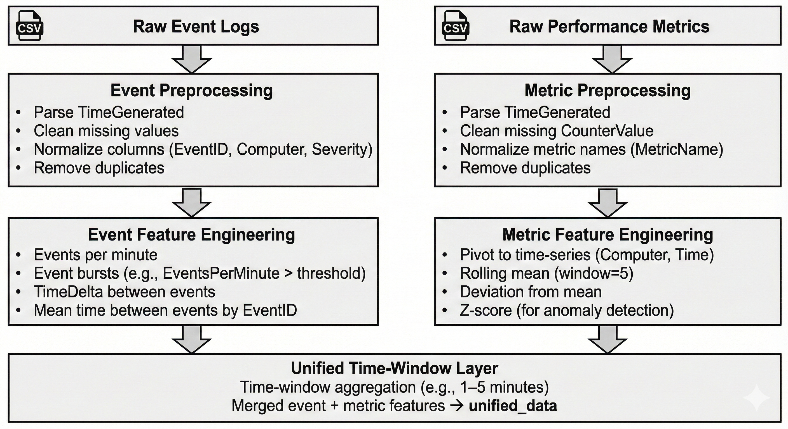

**Phase 2: Knowledge Graph Construction**

* Defined the knowledge graph schema: main entity types (System, Component, Event, Metric, Alert) and relationship types (CAUSES, CORRELATES_WITH, AFFECTS, OCCURS_IN, PRECEDES).
* Built a directed graph with nodes for systems, top events, top metrics, and components, using attributes like node_type and labels.
* Created edges showing how things relate: events occur in systems, components affect metrics, and events that happen close in time precede each other, with weights counting how often they occur.
* Visualized the graph as both a static PNG (matplotlib) and an interactive HTML view (PyVis) for exploration.
* Saved the graph in standard formats (.gexf, .graphml) and reported overall graph stats like total nodes, edges, and density.

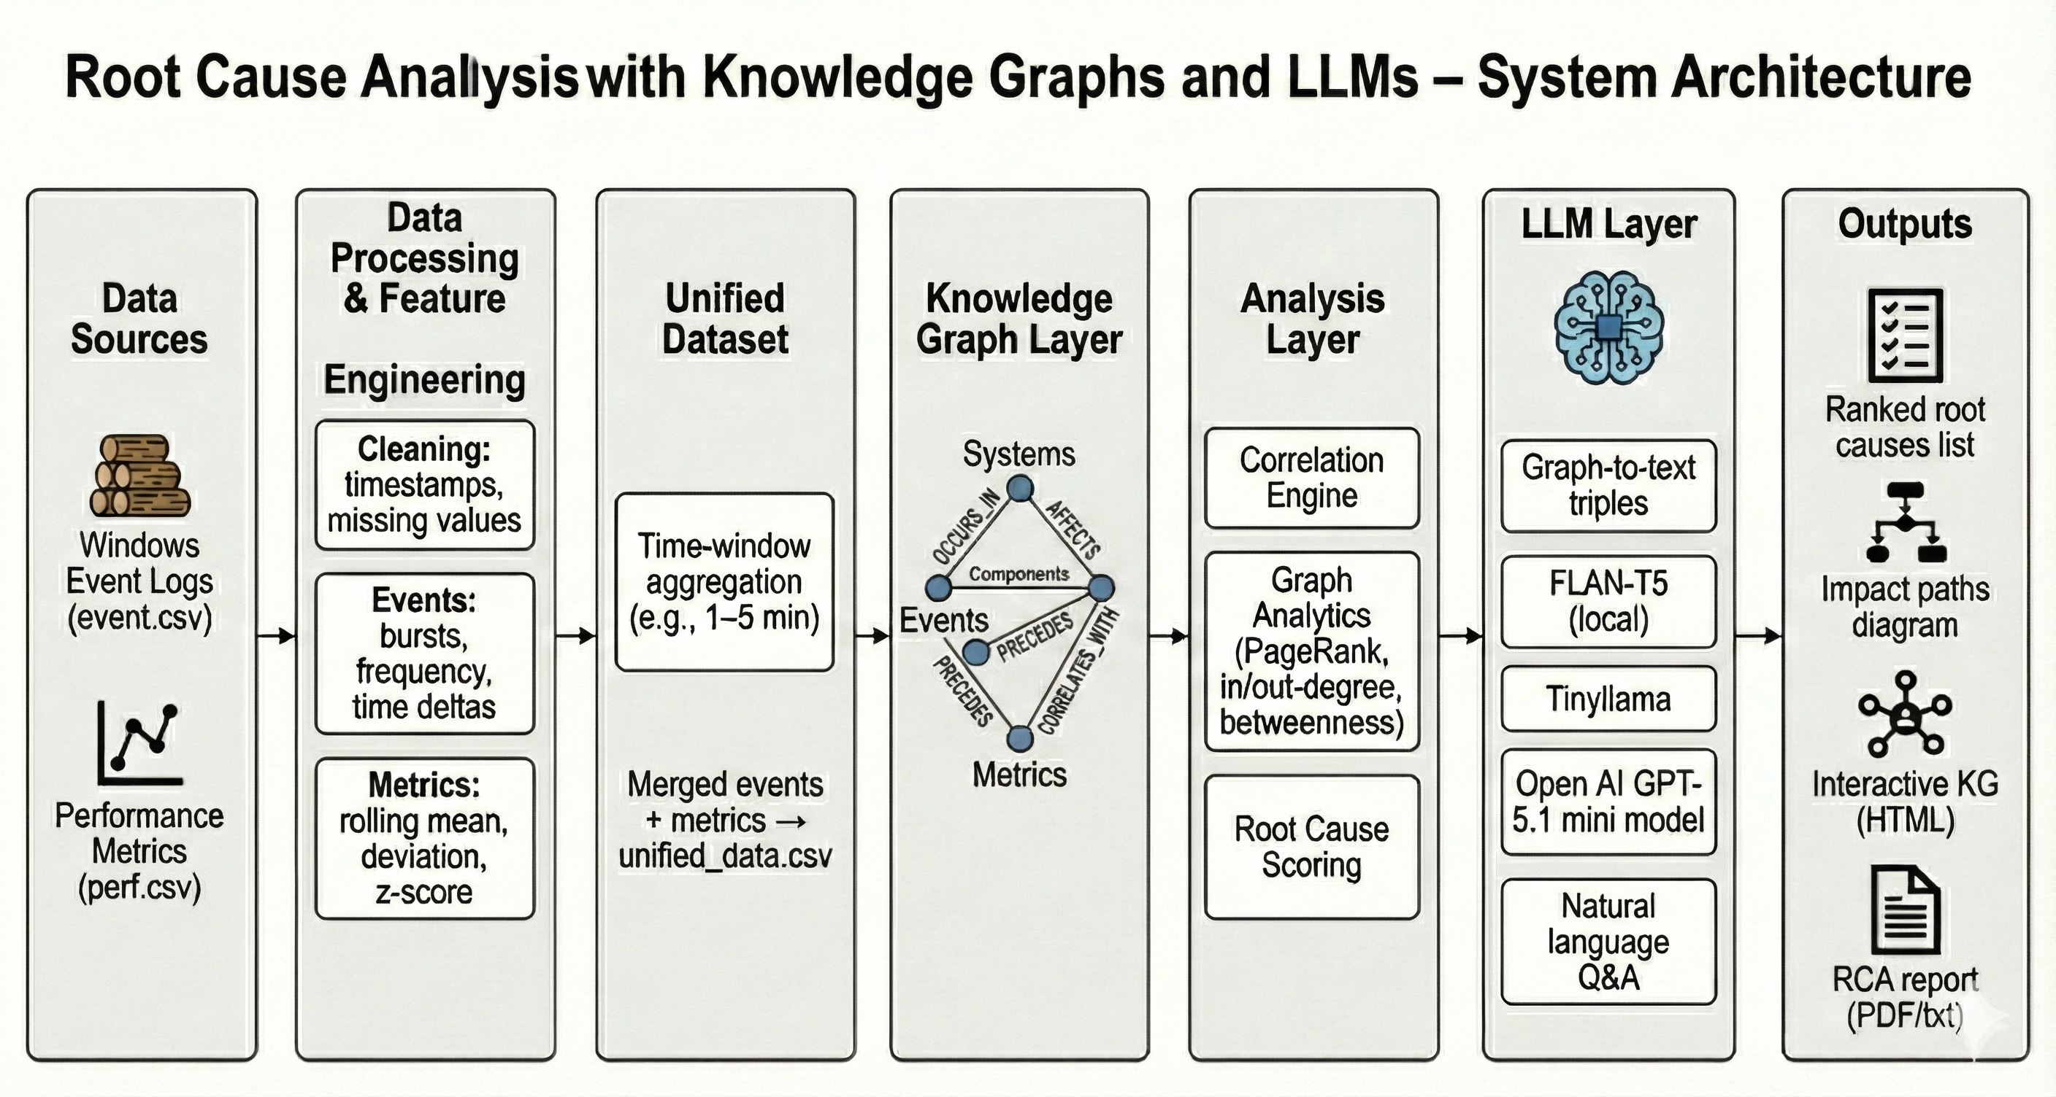

**Phase 3: Root cause and Casual Inferences**

* We grouped events and metrics into 5-minute time windows and calculated how strongly each event moved together with each metric (correlations).
* We added edges in the knowledge graph from events to metrics wherever the correlation was strong, marking whether they rose together or in opposite directions.
* We ran graph algorithms (PageRank, degrees, betweenness) to find which event nodes looked most like root causes.
* From those top root-cause events, we traced short paths through the graph to show how a given event can lead to changes in key metrics (like CPU or Disk).

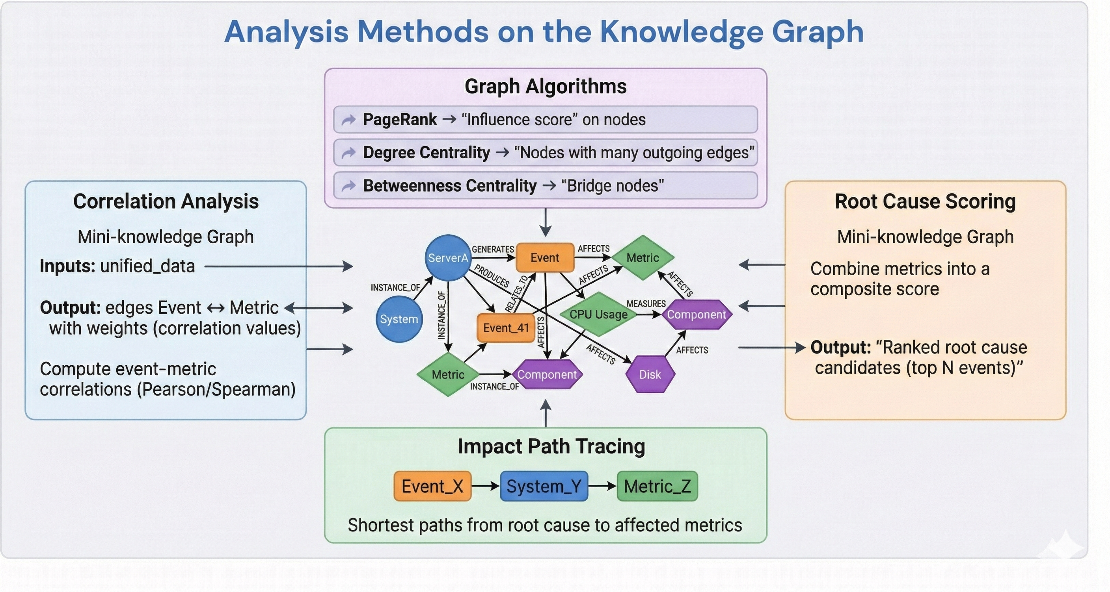

**Phase 4: LLM Integration for Querying**

* Loaded a free local LLM (FLAN-T5 base) and set up a text-to-text pipeline so it can answer questions without any external API.
* Converted the knowledge graph into simple text facts (triples like “Event_41 correlates with CPU_Usage”) so the LLM can read them.
* Built a query function that, given a user question, picks relevant facts from those triples and lets FLAN-T5 generate a natural-language answer.
* Generated a Root Cause Analysis Report summarizing top root-cause events and their impact and saved it to a text file.
* Added an optional second front-end using OpenAI GPT-5-mini, so queries can also be answered by a more powerful API model using the same graph facts.

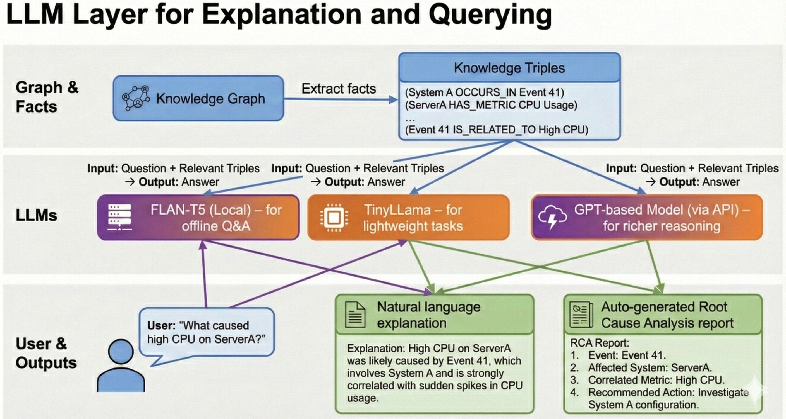

**Results: Example Queries**   
  
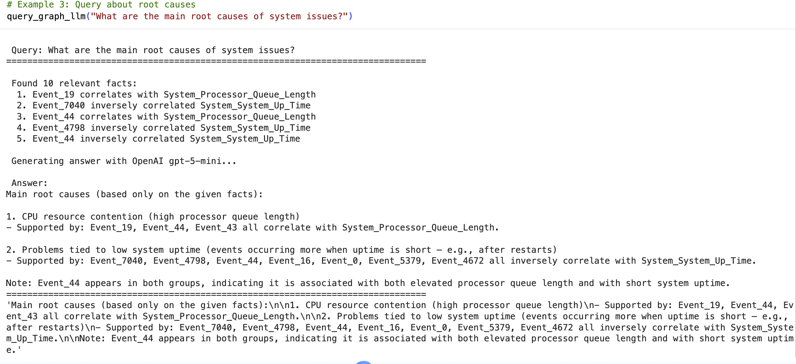  
  
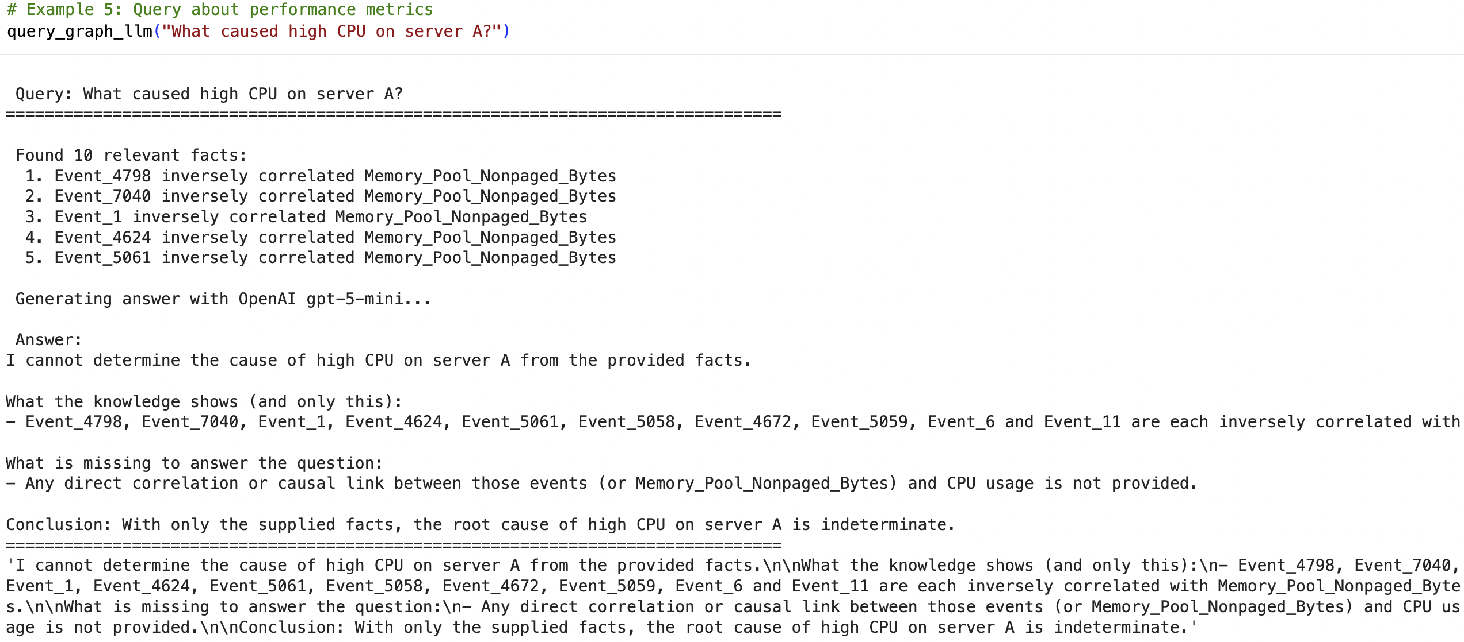  
  
  
**Works Cited**

1. **Cloud forensic analysis: all you need to know – Ackcent**  
    Available at: <https://ackcent.com/cloud-forensic-analysis-all-you-need-to-know/>
2. **Cybersecurity Knowledge Graph: Smarter Threat Detection – PuppyGraph**  
    Available at: <https://www.puppygraph.com/blog/cybersecurity-knowledge-graphs>
3. **Behind the scenes of attack graphs: Vulnerable network generator**  
    Available at: <https://www.sciencedirect.com/science/article/pii/S0167404825002652>
4. **Identifying Evidence for Cloud Forensic Analysis – Academia.edu**  
    Available at: <https://www.academia.edu/109414970/Identifying_Evidence_for_Cloud_Forensic_Analysis>
5. **Cybersecurity Knowledge Graphs**  
    Available at: <https://link.springer.com/article/10.1007/s10115-023-01860-3>
6. **PyRCA: A Library for Metric-based Root Cause Analysis**  
    Available at: <https://arxiv.org/abs/2306.11417>
7. **KGroot: Enhancing Root Cause Analysis through Knowledge Graphs and Graph Convolutional Neural Networks**  
    Available at: <https://arxiv.org/abs/2402.13264>
8. **Root-KGD: A Novel Framework for Root Cause Diagnosis Based on Knowledge Graph and Industrial Data**  
    Available at: <https://arxiv.org/abs/2406.13664>
9. **A Comprehensive Survey on Root Cause Analysis in Microservices: Methodologies, Challenges, and Trends**  
    Available at: <https://arxiv.org/abs/2408.00803>
10. **AIOps for Log Anomaly Detection in the Era of LLMs (Systematic Literature Review)**  
     Available at: <https://www.sciencedirect.com/science/article/pii/S2667305325001346>
11. **Large Language Models for Anomaly and Out-of-Distribution Detection (Survey)**  
     Available at: <https://aclanthology.org/2025.findings-naacl.333.pdf>